

Exor Corporation Limited

The Global Leader in

Infrastructure Asset Management



Exor General User

Guide v4.3



This page intentionally blank

#### 

Quality Assurance Statement

|  |  |
| --- | --- |
| Document Details | |
| **File:**  Exor General User Guide v4.3.pdf | **Prepared by:**  T.C. Stewart |
| **Manual Name:**  Exor General User Guide | **Reviewed by:** |
| **Version:**  3.0 | **Approved for issue by:** |
| **Date of Issue:**  Nov 2010 | **Product Manager:**  T.C. Stewart |
| **File Name:**  Exor General User Guide v4.3.pdf | |

|  |  |  |  |  |
| --- | --- | --- | --- | --- |
| **Document Version Control** | | | | |
| **Revision** | **Date** | **By** | **Page** | **Description** |
| 3.0 | Nov 2010 | IS | All | Reviewed for v4.3 release |

CONTENTS

[Quality Assurance Statement 2](#_Toc149371753)

[*Exor* - Company Overview 6](#_Toc149371754)

[What is *Exor*? 7](#_Toc149371755)

[Support Services 9](#_Toc149371756)

[Extended Support Programmes 9](#_Toc149371757)

[Training 9](#_Toc149371758)

[Who should use this guide 10](#_Toc149371759)

[Notational Conventions 11](#_Toc149371760)

[Field Characteristics 12](#_Toc149371761)

[More Information 12](#_Toc149371762)

[Exor Launchpad 13](#_Toc149371763)

[The Exor Launchpad 13](#_Toc149371764)

[Users 14](#_Toc149371765)

[Creating a New Folder in Favourites 16](#_Toc149371766)

[Adding a Module in Favourites via the ‘Add to Favourites’ option of the context menu 16](#_Toc149371767)

[Adding a Module in Favourites using the Favourites Form 17](#_Toc149371768)

[Calling a Module from Favourites 17](#_Toc149371769)

[Renaming a Folder or menu Item in Favourites 17](#_Toc149371770)

[Deleting a Folder or Item from Favourites 18](#_Toc149371771)

[Using an Exor Form 19](#_Toc149371772)

[General Information 19](#_Toc149371773)

[Function Buttons 21](#_Toc149371774)

[Additional Useful Functions 23](#_Toc149371775)

[Function Keys 24](#_Toc149371776)

[Message Line 25](#_Toc149371777)

[Status Line 25](#_Toc149371778)

[Alert Box 26](#_Toc149371779)

[Additional Module Information 27](#_Toc149371780)

[Using Multiple Forms 28](#_Toc149371781)

[Querying Back Existing Data 29](#_Toc149371782)

[Searching for Information 29](#_Toc149371783)

[How to Search for Information 30](#_Toc149371784)

[List of Values 33](#_Toc149371785)

[Major Features 33](#_Toc149371786)

[Using List of Values 34](#_Toc149371787)

[Fastpath 36](#_Toc149371788)

[Fastpath Screen 36](#_Toc149371789)

[Error Messages 37](#_Toc149371790)

[Dates 39](#_Toc149371791)

[Date Formatting in *Exor* 39](#_Toc149371792)

[User Preferences - HIG1840 40](#_Toc149371793)

[Effective Date 40](#_Toc149371794)

[Setting the Effective Date 41](#_Toc149371795)

[Select Date Calendar 42](#_Toc149371796)

[Unit Name 42](#_Toc149371797)

[Preferred LRM 42](#_Toc149371798)

[Default Region of Interest 43](#_Toc149371799)

[Default Inventory Attribute Set 43](#_Toc149371800)

[User Options 44](#_Toc149371801)

[Change Password – HIG1833 45](#_Toc149371802)

[On-Line Help 47](#_Toc149371803)

[Accessing On-Line Help 47](#_Toc149371804)

[Change the font size in a Help Topic 48](#_Toc149371805)

[Print a Help Topic 48](#_Toc149371806)

[Annotating on-line Help 48](#_Toc149371807)

**CHAPTER**

1

Introduction

Welcome to *Exor*! This Guide provides you with comprehensive and practical information to help you understand the genral principals of the *Exor* product set. It is organised for fast, easy access to detailed information on each of the following topics:

* Introduction to ***Exor***
* ***Exor*** launchpad, menus and forms
* Searching for information
* Using List of Values
* Standard reporting interface

This Guide introduces you to *Exor*, and gives you an overview of the main features that are common across our broad portfolio of applications.

We want you to get the most out of **Exor**!

*Exor* - Company Overview

Exor is part of the Assetwise group and is a division of Bentley systems. Exor supplies the worlds leading Integrated Infrastructure Asset Management Solution.

Based in the UK our software is used world-wide by state, local, national and commercial organisations, including leading utility companies, for network-based asset, maintenance and contract management.

Exor delivers management systems based on advanced database technology from Oracle. These systems address both the management and operational needs of modern transportation and utility organisations

Exor products provide leading tools for network management and asset inventory coupled with unparalleled capabilities in the field of maintenance, tendering and budgetary control.

Specialist applications for Linear Asset based Industies are incorporated as part of the product set. Spatial Manager by Exor provides map-based access to information and interfaces to all leading GIS (Geographic Information Systems). Exor also integrates with popular office systems to integrate word processing, graphs and spreadsheet facilities as well as to specialised engineering packages, unlocking the full potential of an organisation's data through an integrated information system.

Exor offers specialist consultancy services covering data transfer, system implementation and integration. In addition we provide full training services and an international support infrastructure including locally based help desks.

For further information contact:

|  |  |
| --- | --- |
| **Bristol – UK Headquarters**  Bentley Systems Clifton Heights Clifton Bristol BS8 1EJ United Kingdom  Tel: +44 (0)117 900 6200 Fax: +44 (0)117 600 6222 |  |

e-mail: info@bentley.com

http://www.bentley.com/

What is *Exor*?

***Exor***  is a suite of computerised Infrastructure Asset Management database applications that are designed to meet your specific Highways business needs.

It provides significant benefits to an organisation because it not only provides effective tools to run the operational applications, but also provides an integrated solution in a single database. This approach ensures up-to-date and accurate information is always available to both management and operational staff without the need for data duplication and the complex management procedures required to control it. Senior management is then better able to take informed long-term strategic decisions and policies can be more efficiently translated into operational programs.

The end result is efficient, economic and effective management of the highway network.

***Exor*** is developed entirely within the Oracle Relational Database Management System (RDBMS). The use of Oracle RDBMS allows Exor to provide systems that incorporate the benefits of the leading open database technology.

Exor products are modular and fully multi-user providing a single database that can be accessed across an organisation. This means that Exor products are fully scaleable; customers may start small but can be confident in growth both in terms of functionality, by purchasing new modules, and by increasing the number of users over time.

All our products are characterised by a fully data driven design. This means our users define and manage their own data models and so can model their existing data requirements, as well as reflecting their own organisational structure, working practices and legislative requirements.

This ensures ***Exor*** will prove to be a sound long term investment.

***Exor*** consists of a core module, ***Network Manager***, which manages all highway network information and its associated data in a single shared database. Modular applications, working with this single database, are then available which satisfy the operational requirements of a modern Organisation. These include:

|  |  |
| --- | --- |
| * Spatial Manager | * Document Manager |
| * Enquiry Manager | * Maintenance Manager |
| * Street Works Manager | * Street Lighting Manager |
| * Inspections Manager | * Structures Manager |
| * Safety Manager | * Schemes Manager |
| * Pavement Manager | * Traffic Manager |
| * Information Manager * Alert Manager * Audit manager | * Street Gazetteer Manager |

You will have access to one or more of the above modules, other modules can be added at any time by purchasing additional licenses.

Support Services

***Exor*** recognise that the purchase of comprehensive software products should represent a long-term investment. As a result Exor provides a wide range of support services to ensure that clients can make best use of our software and obtain the maximum return on their investment.

***Exor*** provides comprehensive documentation to accompany our products as well as a telephone help desk for day to day support, this is part of our bronze support and is supplied as part of the standard support and maintenance of the system.

Extended Support Programmes

A range of pro-active support packages is available to all users of Exor applications to enable each customer to get the most effective assistance possible for running their day to day business.

The service is supplied by experienced consultants, who have a wealth of experience not only in the applications themselves, but an in-depth knowledge of the business area and detailed experience of the underlying technical architecture of the Oracle database upon which the applications are built. This offers the ability to readily access advice, tips and guidance on use of the products from a wide range of specialists.

The programme is designed to provide differing levels of service, depending on the demands of your business.

The standard support provided with the licensed use of Exor products is known as ***Exor bronze***. The enhanced support packages are known as ***Exor silver, gold*** and ***platinum***.

Training

***Exor*** offer a comprehensive range of training courses covering all aspects of the system, these courses can be tailored to suit your own operational requirements if required.

Training in the underlying Oracle database technology can also be provided and is tailored to form part of the overall training package.

To discuss your training requirements further call ***Exor*** training on

0117 900-6200 (UK)

Who should use this guide

Both inexperienced and experienced users of ***Exor*** will find this Guide useful. This manual covers general principles of ***Exor*** which are relevant to personnel working in Departments, such as:

Data Input Clerks

Technicians

Engineers

Inspectors

Project Managers

Maintenance Personnel or Contractors

This manual assumes that you have an understanding of the terms and functions associated with your organisation. It does not assume you have used ***Exor*** before.

The purpose of this guide is to provide details of ***Exor*** conventions, menus, navigation and using forms to retrieve and work with information.

CHAPTER

2

Using *Exor*

This chapter describes the features which are common to all Modules within Exor. A detailed description of the conventions and functionality is provided.

Notational Conventions

Field Descriptions

***Exor*** form descriptions include detailed explanations for each field. We present the name of each field as a separate paragraph heading. At the same time, we present the ***Exor*** features that are available when you enter each field. We display these field names and features as illustrated below.

**Expand** Select **[Expand]** to display further information for

abbreviated fields in the selected window.

**List** Double click on the field, press **[F9]** or press the ‘Drop Down List’ icon to display a window to view, search and select valid input values for this field.

**Edit** Double click the field to display the full text within the field.

This is available on most fields in ***Exor***. We indicate where you will find it most useful.

**Gaz** Use the Gazetteer to retrieve Group, Element or Network Extent details.

Field Characteristics

***Exor***  form descriptions provide you with the characteristics that apply to each field, including any of the following:

Convention

Status Required, Default List

**Required** This is a mandatory field and ***Exor***  requires you to enter a valid value before you can proceed to other windows.

**Optional** This is an optional field and you can choose not to enter a value.

**Display Only** You cannot enter information into this field. ***Exor*** uses it to display information for you.

**Default *Exor*** automatically enters a default value for this field. You can accept the default value or override it by entering your own value.

More Information

Throughout *Exor*  we alert you to additional or related information you may want to read. We refer you to the appropriate Chapter and Page in this Guide or to other volumes within the documentation set. We highlight these cross-references with an easy to notice graphic hand 🖙 pointing the way to additional information.

Exor Launchpad

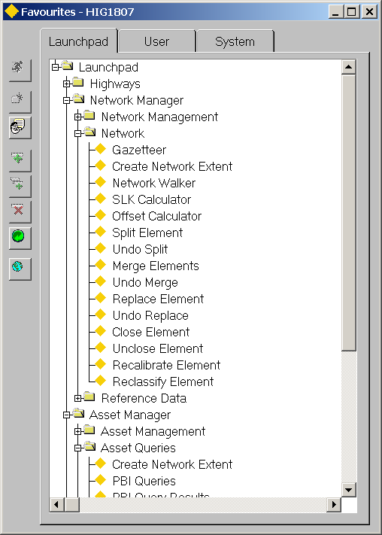Figure 1

Launchpad

The Exor Launchpad

The Exor Launchpad is the means we use to access all the applications. When you first log into the system the above window will be displayed

The Launchpad will display a Folder for each of the Licenced Products within the System. Each Folder may contain a number of sub folders and Application Modules. The application Modules displayed will depend on the User Roles granted to the current User.

An Application module may be launched by double clicking the required module or by pressing the [Run] button on the Launchpad toolbar.

Details of each of the Toolbar buttons are provided on page 15.

Users

Regularly used ***Exor*** Forms can be easily accessed by adding them to the *Favourites* menu. Each User can personalise their *Favourites* menu to suit their own requirements, making the most used Forms or Reports easy to access in the future.

Users personalise their Favourites Menu by amending the ‘User’ panel.

‘Corporate’ or System Favourites may be defined using the ‘System’ panel. This allows an Organistaion to define ‘Key’ modules or call ‘in-house’ reports written in Oracle Discoverer, for example.

Note that ONLY the Exor Owner may create or edit System Favourites.

The *Favourites* menu may be called from the ‘File’ menu option in any of the ***Exor*** Application menus, or by clicking the right mouse button and selecting the *Favourites* option from the context menu. An example of the Favourites menu is shown in Figure 2.

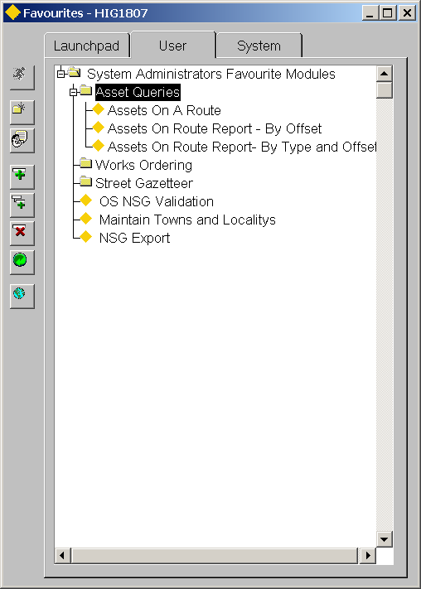Figure 2

Favourites

Several toolbar buttons have been added for use with the Favourites menu.



**Run** This will call the selected module and is only available when a Module Item is selected.



**Select** This option is only available when adding a new

module to the Favourites menu via the ‘Add to Favourites’ option from the context menu



**Create New Folder** This will create a new Folder an is only available when an existing Folder is selected.



**Rename Item** Renames Folders and Menu Items



**Add** This will allow a new Module to be added to the currently ‘Open’ Folder.



**Add Child** This will allow a new Module to be added to the currently selected Folder.



**Delete Item** Deletes an entire Folder or menu Item



**Refresh** Refreshes the menu and closes all folders

Creating a New Folder in Favourites

1. Call the Favourites form via the context menu or from the File menu option.
2. Select the ‘parent’ folder.
3. Press the **[Create New Folder]** button on the Favourites form.
4. This will call a Folder Name dialogue box as shown in Figure 3

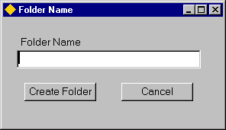Figure 3

Folder Name

1. Enter the required name for the folder
2. Press the ***[Create Folder]*** button.

Adding a Module in Favourites via the ‘Add to Favourites’ option of the context menu

1. Ensure that the required Module is currently ‘open’
2. Call the ‘Context’ menu by pressing the right mouse button.
3. Select ‘Add to Favourites’
4. This will call the Favourites form as shown in Figure 4.
5. Select the Folder to which the module is to be added, or add a new Folder as described above.
6. Press the Select button.

This will call a Module Name Dialogue box as shown in Figure 4

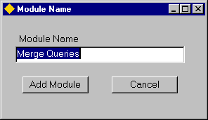Figure 4

Module Name

A default description will be displayed (this is the Module Title as entered in ***Modules – HIG1880***). Edit the description if required.

Press the ***[Add Module]*** button.

Adding a Module in Favourites using the Favourites Form

1. Call the Favourites form via the context menu or from the File menu option.



1. Select either the **Add** or **Add Child** button as required.

This will call the Add Module Panel as shown in Figure 5.

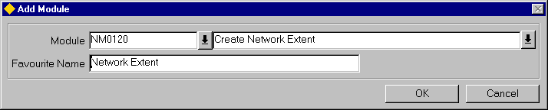Figure 5

Add Module

1. Enter the Module Id of the required Module or select from the List of Values called by pressing the ‘Drop Down List’ icon adjacent to the field.
2. The Favourite Name (visible to the User) will default to the Module Name. This may be editted in the ‘Favourite Name’ field.
3. Press the **[OK]** button.

Calling a Module from Favourites

1. Call the Favourites form via the context menu or from the File menu option.
2. Select the required Module. (To ‘expand’ a Folder press the [+] adjacent to the Folder Name.
3. Press the Run Button.

The appropriate module will be called.

Renaming a Folder or menu Item in Favourites

1. Call the Favourites form via the context menu or from the File menu option.
2. Select the Folder or Module Menu Item to rename.
3. Press the Rename button.
4. This will call the Module Name dialogue box as in Figure 4.
5. Edit the Menu or Module Menu Item as required.
6. Press the ***[Rename]*** button
7. To close the dialogue box press **[Cancel]**.

Deleting a Folder or Item from Favourites

1. Call the Favourites form via the context menu or from the File menu option.
2. Select the Folder or Module Menu Item to be deleted.
3. Press the Delete button.
4. A warning message will be displayed to the User.
5. To Delete the Item press the **[OK]** button.

Using an Exor Form

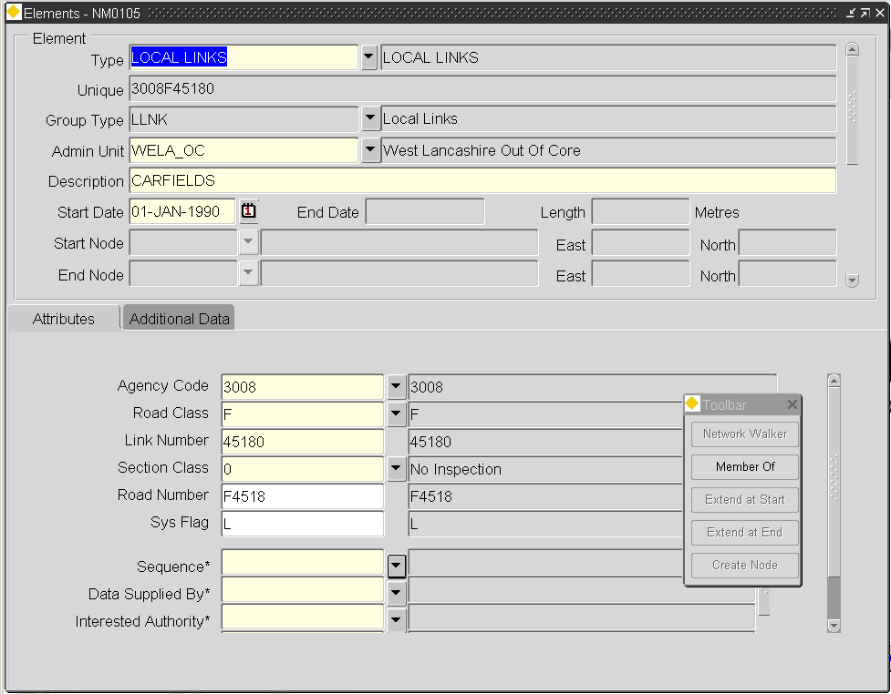Figure 6

Exor Forms

General Information

All ***Exor*** applications consist of a series of forms that allow you to insert, modify or view Exor related data, depending on the mode of access granted to a User. A typical form is displayed above.

All forms have a number of common characteristics.

* Each form has a unique name, for example, NM0105. This name is used by the developers and support staff, if problems are encountered this name should be quoted when contacting support.
* Form name can be viewed once selected using
* Menu | Help | About Current Form
* All forms can be accessed using Fastpath
* Some forms contain buttons that will lead to additional windows being displayed.
* Mandatory fields are displayed in light yellow
* In query Mode, queryable fields are displayed in Cyan

The Form title banner can display the following information when Product Option **DBWINTITLE** is set to ‘**Y**’. An example is shown in

Figure 7.

* Username
* Database Alias
* Server Name
* Current Highways Product (e.g. NET)
* Version Number of the current Product

Figure 7

The Module ID may also be displayed within the Form title Banner by setting Product Option **IDWINTITLE** to '**Y**'. An example is shown in Figure 8. (Note that DBWINTITLE is set to 'N' in this example.)

Figure 8

Each form is comprised of a number of fields that can contain data. Fields:

* are used to 'query' back existing data .
* can be 'display only' or 'updateable'. Display only field are ‘greyed’ out for easy identification.
* can have associated lists of values. Fields with an available List of Values can be identified by the ‘Drop Down List’ icon adjacent to the field.
* may contain default values.
* can validate the format and content of data entered if required.
* help text and prompts will be displayed in the message line

Multiple forms can be displayed at any one time

Function Buttons

***Exor*** forms have a common look and feel. You should, therefore, be able to learn to use the system quickly. Common functions are performed in the same way on each form and are driven by a series of function buttons.

Figure 9

Buttons

When a form is selected the toolbar above will be displayed, this toolbar contains buttons that represent commonly used functions when using a form. Additional less used functions can be found in the pull down menu above the toolbar.

The buttons are context sensitive and will be greyed out if they are unavailable for use at any time.

The following buttons become available when a form is selected.

**Enter Query**, changes the form's status so the user can enter some query criteria, Wildcards may be used

**Execute Query**, executes the query based on the criteria entered.

**Count Query Hits**, displays the number of records that match the query criteria entered, you may wish to enter additional criteria to reduce the records retrieved.

**Cancel Query**, this will return the form to insert mode. You must cancel a query before you will be able to exit the form.

**Expand**, shows any additional information on the selected record.

**Documents**, call the document manager interface, displays all documents associated to the selected record.

**Create Record**, add a new record into the database.

**Delete Record**, removes a record from the database. Records are

generally end-dated and are not completely removed from the system.

**Clear Record**, clears the record from the form.

**First Record**, move to the first record in the series retrieved.

**Page Up**, in a multi-record window page up 80% of the windows contents.

**Up**, move up one record at a time.

**Down**, move down one record at a time.

**Page Down**, in a multi-record window page down 80% of the windows contents.

**Last Record**, move to the last record in the series retrieved. This could take some time if many records have been retrieved.

**Print,** generally prints the screen to the printer.

**Save**, save any changes made to the database.

**Show Map**, Toggle to ***Locator*** for the currently selected spatial item. For example road section, inventory, accident, street lighting column etc.

**Find**, used to refine a search in some applications.



**Toolbar**, used to toggle a Floating Toolbar on or off in some modules..



**Help**, display on line help.

**Exit**, exit the form, if changes have been made you will be prompted to save the

changes.



**Mode Indicator**, displays the mode of access the current User has to the open Module. This will either be Normal or Readonly.



**Effective Date**, displays the Effective System Date.

**Gazettee**r, call the gazetteer.



**Clear Region of Interest**, clears the currently defined Preferred Region of Interest



Additional Useful Functions

All the commonly used functions will have an associated button, however, when entering large amounts of similar data the **[Duplicate Record]** function is useful.

To use this function follow this procedure:

1. Using the querying techniques detailed on page 33, retrieve the record you wish to copy.
2. Select **[Insert Record]** to create a new record
3. From the menu, select Record | Duplicate. This will copy the contents of the record retrieved in step 1 into the current record.
4. Make the changes to this copy, **[Save]** the changes made.

Other useful functions are detailed later in this chapter.

Function Keys

When entering data it is sometimes more convenient to use the function keys on your keyboard instead of selecting a button with the mouse.

All the function buttons within Exor have a function key associated with them.

To view the function keys select Help | Keys from the menu, the following window will be displayed:

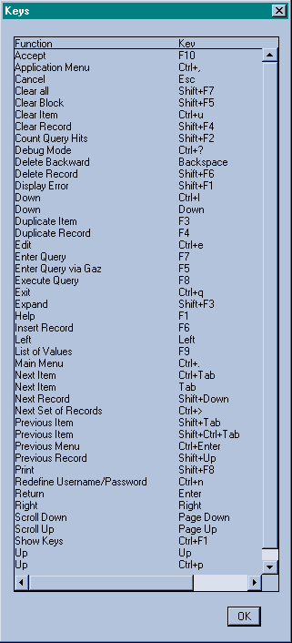Figure 10

Function Keys

Like the buttons, the keys are context sensitive. The above list of keys will differ depending on where the list of keys was requested.

When a form is selected a message and status line will be displayed at the bottom of the screen.

Figure 11

### Message Line

### Status Line



Message and Status Lines

Message Line

Figure 11 illustrates the Message Line at the bottom of the screen. You’ll get the following types of information:

Automatic help, guidance on what to enter in a field

Information, warning and error messages.

Status Line

Figure 11 illustrates the Status Line below the Message Line and displays system information such as:

|  |  |
| --- | --- |
| Count | Tells you the number of records you have viewed on the screen. As you scroll forward through records the count increases. This information is always visible. An asterisk (\*) next to the count value indicates you are at the last record. |

|  |  |
| --- | --- |
| ^ | Tells you that there are records before or after the current record. |

|  |  |
| --- | --- |
| ENTER QUERY | Tells you that you are in query mode. This allows you to enter your selection criteria. Press [Execute Query] to retrieve data or [Cancel] to cancel the query. For more information see Querying back Existing Data. |

|  |  |
| --- | --- |
| <List> | The <List> option indicates there is a list of values available |

Figure 12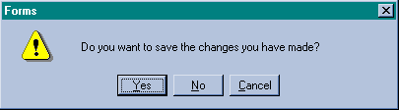

Alert Box

Alert Box

An Alert Box pops up when ***Exor*** finds an unfinished piece of work. Figure 12 illustrates a typical alert box. For example, if you attempt to leave a form or enter a query without saving (committing) your latest changes, you are prompted to select one of the following options:

**(Yes)** saves changes to the database

**(No)** discards the changes to the database

**(Cancel)** allows you to continue the unfinished piece of work.

There are a number of alert boxes, the message should be read prior to making a selection.

Figure 13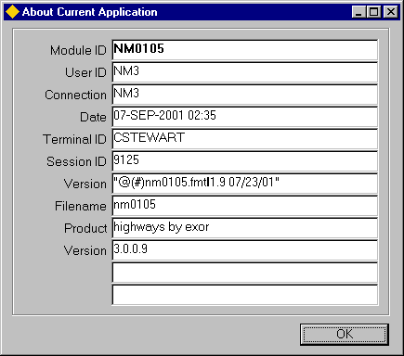

Additional information

Additional Module Information

If you require additional information regarding the selected module, for example, you need to obtain the unique module id. From the strip menu above the buttons select Help | About Current Form**,** the window above will be displayed.

Select **[OK]** to remove the window.

Using Multiple Forms

It is possible to use several forms at once. This will allow you to, for example, view data on one form whilst updating related data on a separate form. These forms can all be from one application or from multiple applications.

To view multiple forms in the same application carry out the following procedure

1. Select the first form, query back the relevant data.
2. From the menu above the buttons, select Action | Switch to application, the menu will now change displaying the menu for the current application.
3. Select another form. Query back the relevant data.
4. Repeat steps 2 and 3 to view additional forms.
5. To make one of the visible forms active select the form, then select one of the fields in the form. Forms can also be selected by selecting window from the menu, the active forms will be displayed in a list, select the required form.

To view multiple forms in a different application carry out the following procedure

1. Select the first form, query back the relevant data.
2. From the menu above the buttons, select Action | Switch to Application, the menu will now change displaying the menu for the current application, select Action | Return to Launchpad, this will display the launchpad.
3. Select the required application.
4. Select another form. Query back the relevant data.
5. Repeat steps 2 to 4 to view additional forms.
6. To make one of the visible forms active select the form, then select one of the fields in the form. Forms can also be selected by selecting window from the menu, the active forms will be displayed in a list, select the required form.

Querying Back Existing Data

Within all ***Exor*** products you can use relational database search capabilities to retrieve information in your database.

You can retrieve information in your database. You can find this information quickly and easily.

You can search for a specific item of information or for related information based on search criteria without having to review all the information in your database.

You can search for information based on any type and quantity of search criteria, including a single letter, a single word, a group of characters or anything else you wish to enter.

You can find out how much information is available that satisfies your search criteria before running the search. This may save you time should your search for a single piece of information yield 10,000 responses.

Searching for Information

***Exor***  uses the term *query* to mean searching for information.

Entering and Executing a Query

To retrieve information from the database, you must enter a query and execute it. This means you must enter the condition or values, *criteria.*  ***Exor***  will use to search for information. When you select **[Enter Query]**, you are in Enter Query Mode and you are ready to enter query criteria. The message ENTER QUERY will be displayed in the status line

Once you are in Enter Query Mode, you have two options:

You can enter your query criteria and run (*execute*) the query by selecting **[Execute Query]**.

or

You cancel Query Mode by selecting [Cancel], you will not be able to exit the form until the query has been cancelled.

If you get the following message when you run your query:

Query cause no records to be retrieved. Re-enter.

either enter different query criteria or cancel the query.

When a query retrieves information, ***Exor*** displays it on-screen. You don’t need to print out lengthy reports in order to see it.

Count Query Hits

In Enter Query Mode, select **[Count Query Hits]** to see the number of rows a query will retrieve. With Count Query Hits you can quickly determine how much information is in your database without actually displaying the data on your screen.

Reviewing Records

After ***Exor*** retrieves information, it displays the information on the screen. Some forms display one row at a time (single-record windows) and others display several rows at a time (multi-record windows). To display records which have been retrieved by your search but are not currently visible on the screen use **[Up]**, **[Down]**, **[Page Up]** and **[Page Down]**. We call this *scrolling* through records.

To recap, the usual query sequence is as follows:

1. Select [Enter Query]
2. Type in your query criteria
3. Select [Execute Query]

How to Search for Information

There are a variety of search methods available to you whenever you want to retrieve information in your database. Some forms go into query mode automatically when they are selected, ***Exor*** will tell you when **[Enter Query]** is available.

An Exact Match

You can retrieve just the information that matches your query criteria. For example, you may wish to review all Links with a section class of All Purpose. Enter ‘AP’ in the appropriate field and ***Exor***  will retrieve and display the Links that match this criteria. You can enter any search criteria you want to find just the information you need.

Using Comparative Searches

You can restrict by entering comparison using the following operators:

**>** Greater than

**<** Less than

**>=** Greater than or equal to

**<=** Less than or equal to

For example, to display all records where values in a particular field are more than 1000, you select **[Enter Query]**, move the cursor to the field and type >1000 followed by **[Execute Query]**.

“Fuzzy Searches with Wildcards”

You can enter inexact (fuzzy) query criteria. To do this you use one or more wildcards. There are two wildcards that you can use:

% percent takes the place of one or more characters or potentially no characters.

‘-’ underscore takes the place of a single character.

For example, you may wish to search for Links with a Linkcode of A1 or A10, enter ‘A1%’ followed by **[Execute Query]**. ***Exor***  wildcards let you find this information quickly, without having to search each row individually.

To run a search for all descriptions containing the word “junction”, enter ‘%junction%’ in the appropriate field, some fields are case sensitive, if your search results in no records being retrieved try the other case.

To search for all 100 series budget codes enter '\_100%', this will retrieve all 'A100', 'B100', 'C100'….'n100' series budget codes.

Initiating a Global Search

Initiating a global search is not recommended because the system will bring back all records, this could take some time on larger databases. If you execute a query without entering any query criteria, you are not restricting the data that will be retrieved. It is better to restrict your query using a combination of specific criteria and wildcards. If a global search is carried out it is recommended that **[Count QueryHits]** is used to establish how many records will be retrieved.

If a large number of records are retrieved it is not recommended that the **[Last Record]** button be selected, this will take a long time to retrieve the last record and may have the effect of 'hanging' your PC.

Figure 14

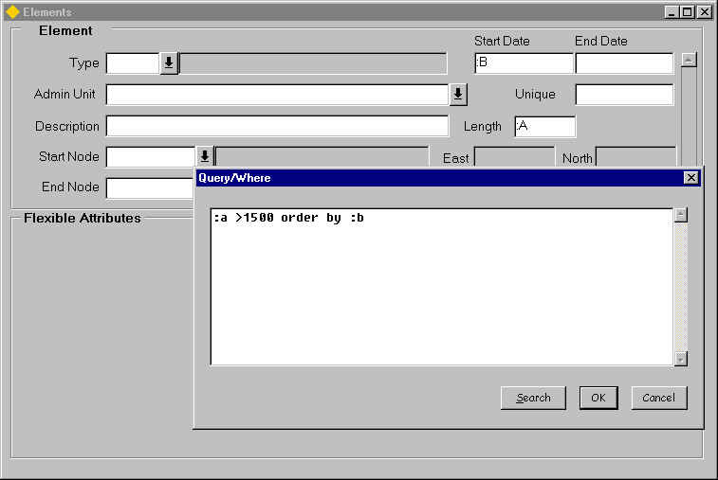Query Where

Query Where Box

The Query Where Box allows you to enter complex search criteria, exploiting the full power of the Structured Query Language (SQL). Figure 14 illustrates the use of Query Where to search for all sections with no adoption status and order the results by the section description.

To use Query Where, follow the following steps:

1. Select [Enter Query].
2. Enter a variable in each field you want to reference; you can use more that one field in your query. The variable should begin with a colon or an ampersand as illustrated in Figure 14.
3. Select [Execute Query] to display the Query Where Box.
4. Enter the query criteria in the Query Where Box.
5. Select [Save] to run the query.

The advantage of using Query Where is that you can fine tune your search criteria. If you simply enter criteria directly into fields on screen, the information retrieved must satisfy all the criteria. Using Query Where you can vary the criteria.

You can have a query where expression for more than one field if required. When you do this you will need different labels in each field, for example, ‘:A’ in the first field and ‘:B’ in the second etc.

List of Values

List of Values provides you with an easy-to-use data entry and search method that increases your accuracy and productivity:

1. You can enter data quickly and easily without having to memorise or look up valid data for each field.
2. You can choose from an on-line list of acceptable input choices whenever you want.
3. ***Exor***  will validate your input during data entry. If you enter incorrect data, you know right away so you can make corrections.
4. The ‘Drop Down List’ icon adjacent to the field easily identifies fields with an associated List of Values.

Major Features

List Option

***Exor***  displays the List option when List of Values is available for a field. You will see the word <List> on the status line at the bottom of the screen.

Dynamic Lists

When a list of values is displayed, entering a character from the keyboard will automatically reduce the contents of the list to those values starting with the character entered.

Wildcard Search

The wildcard search facility simplifies and speeds your data entry. When you display the List of Values window, you have the option of reducing the List of Values to just those containing the characters you want by entering a value in the Find field, wildcards may be used in this field.

Figure 15

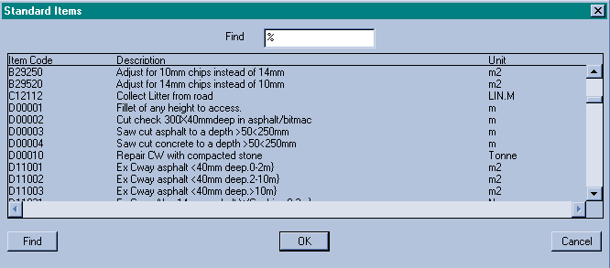List of Values

Using List of Values

List of Values - The Basic Steps

A List of Values is available whenever the <List> options appears on the status line at the bottom of the screen.

In a field where the <List> option appears 'double click' the field with the mouse or press the [F9] key. The List of Values window appears with a descriptive heading, the list window can be resized if required by selecting on the edge or corner of the window and dragging the window. A % will be displayed in the find field indicating all the values will be displayed.

A count of the total number of entries in the list will be displayed on the message line.

To make a selection from the List, either, 'double click' the item required or select the item followed by **[OK]**.

Restricting the content of the list

The contents of the list can be reduced in 1 of 2 ways.

Select a character using the keyboard, this will restrict the content of the list to all those values beginning with the character selected, 'A' was selected in the example below.

Figure 16

Restricting

List of Values (1)

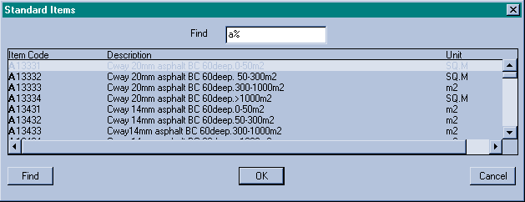

The content of the list has been reduced and an 'a' is displayed in the find field

Click in the find field and enter the text string that you wish to search for followed by [Return], '%joint%' was selected in the example below.

Figure 17

Restricting

List of Values (2)

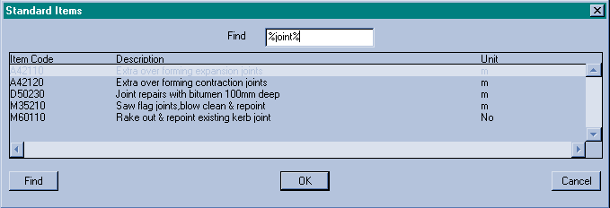

The content of the list has been reduced to all items containing the word 'joint'.

To return to the full list clear the contents from the find field followed by **[Return]**

To remove the list of values select ***Cancel***.

Fastpath

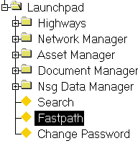Figure 18

Fastpath menu

The Fastpath screen allows the user to move directly to a specified module by typing the module ID or Module Title (wildcards may be used) into the appropriate fastpath field without moving through the menus to the required option.

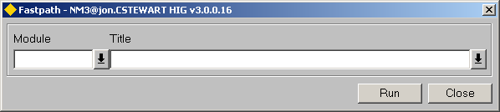Figure 19

Fastpath

Fastpath Screen

This screen is used to move directly to a selected module.

Module Id (Optional) List

Enter the full ID of the module you wish to move directly to, for example, NM7050.

Title (Optional) List

Enter the Title of the module you wish to move directly to, for example, Groups of Groups.

Error Messages

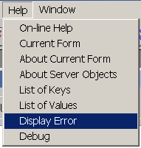Figure 20

Error Messages

Occasionally when working within ***Exor*** a database error may occur, a window similar to the one above will be displayed informing you of the error.

Additional information about the error should be displayed by selecting Help | Display Error from the menu, a window similar to the one below will be displayed:

Figure 21

Error Messages

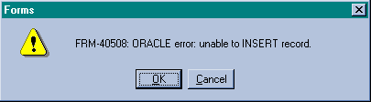

Figure 22

Database Errors

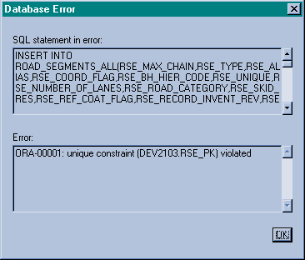

Errors of this type should be reported to the **Exor** help desk.

When this window is displayed, print the screen and paste it into a document, this document can then be faxed or emailed to the help desk.

Giving the help desk this information together with details of any data being processed at the time and what function had been selected ([Save] etc.) will help them solve the problem as quickly as possible.

Dates

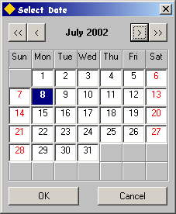Figure 23

Date Formatting in *Exor*

A date may be selected in any Date field by right clicking the Mouse button and selecting the ‘Today’ menu option from the context menu or by selecting the required date from the ‘Calendar’ option as shown in Figure 23

Note that the ‘Hot Key’ F3 will populate the System Date in Date fields when pressed.

User Preferences - HIG1840

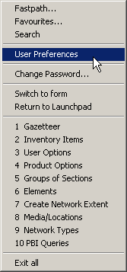Figure 24

The ***User Preferences*** window is used to define certain default values for a User such as the 'Effective Date' (page 40) and to manage a Users User Options. It may be called by selecting the 'User Preferences' option from the 'File' menu as shown in Figure 24 or by pressing the ‘Preferences’ button on the menu toolbar when a form is active.

Figure 25

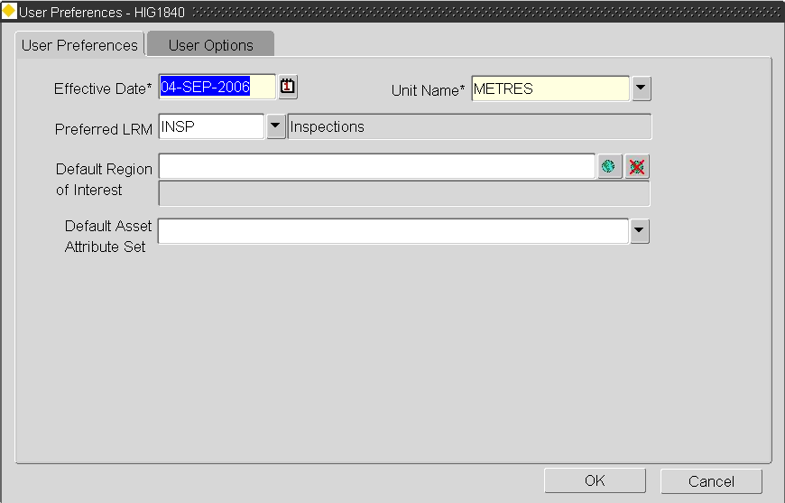

Effective Date

***Exor*** are commited to providing a fully accountable, auditable Network Management system. For this reason very few ‘Objects’, e.g. Network Elements, Network Groups, Inventory Items etc., are ever deleted from the system, they are instead ‘End Dated’ which effectively hides them from the User.

A Network and any associated objects may be viewed as they were at previous temporal stages by setting the ‘Effective Date’ to the required date. This will allow any Network Elements, Groups, Inventory Items etc., with a Start Date which is equal to or greater than the selected ‘Effective Date’ to be displayed.

The Effective Date will be ‘Active’ for all Forms and will remain in affect until the current User session is ended or the ‘Effective Date’ is reset. When an Effective Date is selected no database updates or inserts will be allowed in any of the ***Exor*** forms.

Note that Network Extents may be created when an Effective Date is set to a Date which is not today.

EFF DATEFigure 26

Effective Date

The Effective Date selected will be displayed on the ***Exor*** menu toolbar as shown in Figure 26. If an Effective Date, which is not the current system date, is selected it will be displayed in Red to indicate that no database updates or inserts are allowed.

Setting the Effective Date

To change the ‘Effective Date’ enter the required Date in the ‘Effective Date’ field. To select a date from the calendar, click the right mouse button and select the ‘Calendar’ option from the context menu. This will call a ‘Select Date’ calendar window (Figure 27).

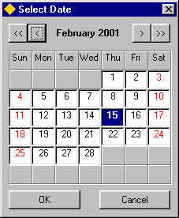Figure 27

Calendar

Note that pressing the F3 key will populate the current System Date into the Effective Date.

Select Date Calendar

The Select Date Calendar allows the selection of a Date at any temporal stage.

The following buttons are available to navigate through the calendar to select the required date.

Move back one Month

CAL_BACK M ONTH

Move back one Year

CAL_FORWARD_MONTH

Move forward one Month

CAL_BACK YEARCAL_FORWARD YEAR

Move back one Year

When the required date has been selected press the [**OK**] button.

Unit Name

The preferred Unit of Measurement used to display Element Lengths in the ***Elements – NM0105*** may be selected in the ‘Unit Name’ field. The avalaible Units will have been defined in the ***Units and Conversions – HIG1820*** form.

Preferred LRM

The User Preferred LRM or Linear Group Type may be defined by selecting the appropriate LRM from the List of Values. The Preferred LRM is used throughout ***Exor.*** For example, if a Preferred LRM is currently set and the Gazetteer is called, the Group Type and associated Network Type will be automatically populated in the appropraite fields. When viewing Assets, their locations will only be displayed relative to the Preferred LRM unless the Asset is not located on a Route of that Type, in which case the location will be displayed relative to ALL other LRMS on which the Asset is located.

To set a Preferred LRM select the appropraite Linear Group Type from the LOV. If a Preferred LRM is not required the User should select the ***ALL LRM'S*** value.

Note that if a User selects the ALL LRM'S value and Product Option PREFLRM has been set, the value entered for the Product Option will take precidence. If this is not desirable no value should be entered for the Product Option.

Figure 28



Default Region of Interest

A User default Region Of Interest (ROI) may be defined by selecting the appropriate Group or Saved Network Extent from the Gazetteer. The Gazetteer may be called by pressing the **[Gazetteer]** button adjacient to the Default Region of Interest field. To cancel the Default ROI press the **[Cancel ROI]** button.

The Default ROI is used in modules such as ***Inventory Items - NM0510*** for example and will be displayed in the ROI field on the menu Toolbar. When a User calls such a module the Region of Interest is set without needing to call the Gazetteer.

Note that the Default Region of Interest may be 'cleared' within each module which uses the value without needed to Clear the Default ROI from within the User Preference Module.

If the Default ROI selected is a Saved Network Extent, this same extent of Network of will be used within ***Spatial Data Manager***, therefore limiting the Network, and any events added to it, to this Region.

Refer to the Network Manager User Guide for information on setting the Default Region of Interest from the Gazetter.

Figure 29

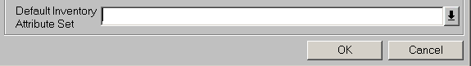

Default Inventory Attribute Set

A User default Inventory Asset Set may be defined by selecting the required Set from the LOV. Inventory Attribute Sets are used to restrict the Attributes and Attribute values displayed for an Asset Item in modules such as ***Assets on a Route - NM0560*** (refer to Asset Manager User Guide) and some ***Asset Reports***. Attribute sets are maintained using ***Inventory Attribute Sets - NM0415*** (refer to the Asset Manager System Admin Guide).

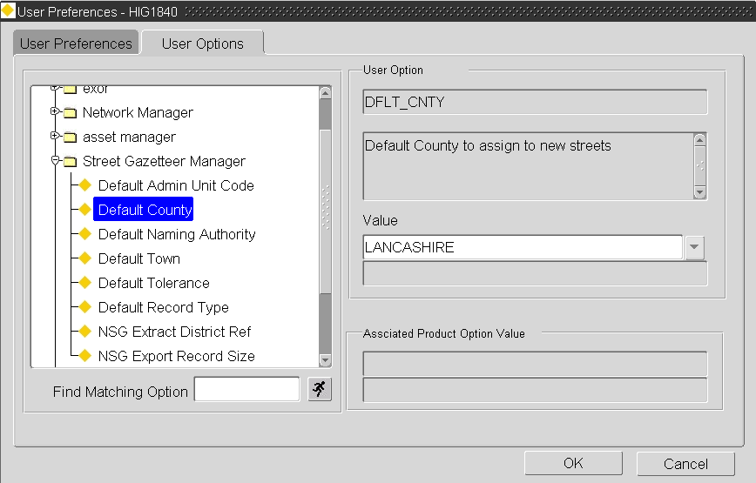Figure 30

User Options

Each User may have a set of 'switches' or default values that affect how certain modules work. These are called User Options. User Options are similar to Product Options but are specific a User and not all Users of the System as is the case for a Product Option. Some User Options are also specified as Product Options, e.g. **SHOWINVPK**. If this is the case the value of the User Option (if assigned) will take precedence.

The User Options for each licenced Product are displayed within the Tree on the Left Hand Side. The tree is context sensitive and will ‘open’ at the appropriate branch according to the module from which the User Preferences form is called.

Change Password – HIG1833

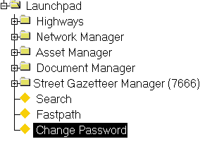Figure 31

Change Password

The Change Password – HIG1833 option allows a User to change their Log on password. It may be accessed via the Fastpath or by selecting ‘Change Password’ option from the File menu on the menu toolbar. When the Password has been sucessfully changed and saved the User will be Logged out of Exor and must Log in again using the new Password.

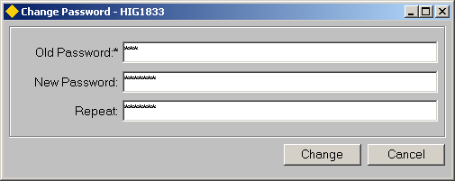Figure 32

Old Password (Required, Masked)

Enter the existing Password. If the Password is incorrectly entered a message will be displayed to the User as shown in Figure 33.

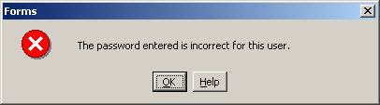Figure 33

New Password (Required, Masked)

Enter the required new password. A maximum of 30 characters is allowed.

Repeat (Required, Masked)

Re-enter the new password.

If the passwords entered differ a message will be displayed warning the User as shown in Figure 34

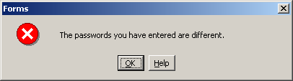Figure 34

The required password should be corrected before pressing the **[Change]** button. Once the **[Change]** button is pressed a message will be displayed warning the User that the current session will be terminated as shown in

Figure 35 . Press **[OK]** to change the password and Log out or **[Cancel]** .

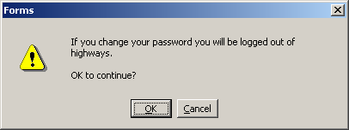Figure 35

On-Line Help

***Exor*** provides full context sensitive On-Line Help facilities to assist users in the use of Highways modules. This Online Help provides detailed information about each form including general information and field characteristics.

Step by Step Guides are also available and can be viewed by clicking the **[Step by Step]** button where available.

Users can browse through the help books using the Contents tab, search for Topic titles using the Index tab or search for specific words or phrases using the Find tab.

Specific ***Exor*** forms can be searched for by either typing in the forms Name e.g. *Network Elements* or by typing in the fastpath for the form e.g. *NM0105*.

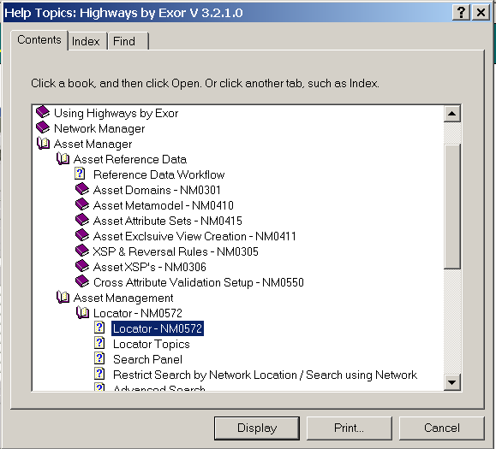Figure 36

On-Help Topics

Accessing On-Line Help

On-Line help can be accessed by a number of different methods.

Method 1

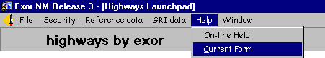

On the menu, press Help | On-line Help. This will display the Help for the currently selected Highways product.

Method 2

From within a *Highways* form press the  button. This will automatically 'bring in' in currently selected *Exor* form name in the 'Topic Index' box. To display the help information press the [Display] button.

Change the font size in a Help Topic

In the Help topic window, click Options

To change the font size, point to Font, then click Small, Normal or Large.

Print a Help Topic

In the Help topic window, click Options

Click Print Topic.

Annotating on-line Help

Users can 'personalise' their help files by adding comments or notes to individual topics. These will be saved and can be recalled later by clicking on the paper clip symbol that will appear against the topic header.

In the Help Topic window, click the **Edit** menu or the **Options** button.

You can also use the right mouse button to click inside the topic.

Click **Annotate**, and then type your comments or notes.

When you're done, you'll see a paper-clip icon at the top of the topic. You can click it to see or change your comment.

Index

A

Alert Box 25

C

Change Password 44

D

Dates 38

**DBWINTITLE** **18**

Default Region of Interest 42

E

Effective Date 39, 40

Error Messages 36

F

Fastpath 35

Function Keys 23

H

HIG1833 - Change Password 44

HIG1840 - User Preferences 39

I

**IDWINTITLE** **19**

L

Launchpad 12

Call a Module 16

Exor Launchpad 12

User Launchpad 13

List of Values 5, 16, **19**, 32, 33, 34, 41

M

Menu Toolbar 20

Cancel Query 20

Clear Record 20

Clear Region Of Interest 21

Count Query Hits 20

Create Record 20

Delete Record 20

Documents 20

Down 21

Effective Date 21

Enter Query 20

Execute Query 20

Exit 21

Expand 20

Find 21

First Record 20

Gazetteer 21

Help 21

Last Record 21

Mode Indicator 21

Page Down 21

Page Up 20

Print 21

Save 21

Show Map 21

Toolbar 21

Up 21

Message Line 24

N

Notational Conventions 10

Field Characteristics 11

Field Descriptions 10

O

On-line Help

Change Font Size 47

On-Line help

Print a Topic 47

On-Line Help 46

Accessing On-Line Help 46

Annotate 47

P

Preferred LRM 41

Q

Querying Back Existing Data 28

Count Query Hits 29

Entering and Executing a Query 28

Searching 29

S

Searching

An Exact Match 29

Global Search 30

Query Where 31

Using Comparative Searches 29

Using Wildcards 29

Status Line 24

Support Services 8

T

Training 8

U

User Launchpad

Add a Module 15

Create a new Folder 15

Delete a Folder 17

Folder 15

Rename a Folder 16

User Options 43

User Preferences 39

Using an Exor Form 18

Using Multiple Forms 27